**Response for Assignment 1.4**

Below screenshot shows the response of output of the program which will calculate the volume of sphere which has diameter of 12 cm. Left side shows source code and right side shows output.

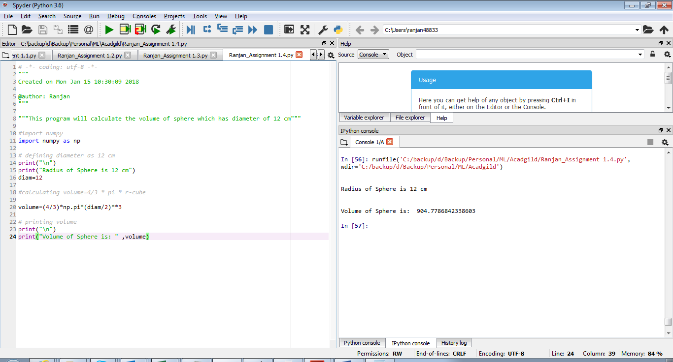

**Source Code**

"""This program will calculate the volume of sphere which has diameter of 12 cm"""

#import numpy

import numpy as np

# defining diameter as 12 cm

print("\n")

print("Radius of Sphere is 12 cm")

diam=12

#calculating volume=4/3 * pi * r-cube

volume=(4/3)*np.pi*(diam/2)**3

# printing volume

print("\n")

print("Volume of Sphere is: " ,volume)